Java Stream :

Stream can be created from different element sources e.g. Collection or array with the help of stream() or static method of().

A stream() default method has been added as a default method in Collection interface and allows creating a Stream<T> using any collection as an element source.

package com.java8;

import java.util.ArrayList;
import java.util.Arrays;
import java.util.List;
import java.util.stream.Stream;

public class ClientTest {

public static void main(String[] args) {

String[] arr = new String[] {"AA","BB","CC","DD"};
Stream<String> stream =Arrays.stream(arr);
stream.forEach(System.out::println);
System.out.println("------------------------------------------");
Stream streamOf = Stream.of('A','B','C','D');
streamOf.forEach(System.out::println);
System.out.println("------------------------------------------");

List<String> stringList = new ArrayList<>();
stringList.add("India");
stringList.add("Australia");
stringList.add("England");
stringList.add("Russia");

Stream<String> listStream = stringList.stream();
listStream.forEach(System.out::println);

}

}

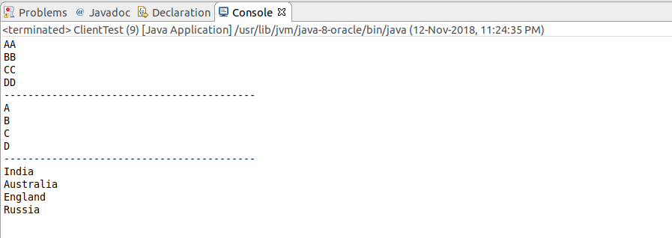

Multi-Threading with Streams :

Stream API also simplifies multithreading by providing the parallelStream() method that runs operations over stream’s elements in parallel mode.
The code below allows to run method doWork() in parallel for every element in the stream ::

list.parallelStream().forEach(element -> doWork(element))

Student.java

package com.java8.model;

public class Student {

private String name;
private int age;

public Student(String name, int age) {
super();
this.name = name;
this.age = age;
}

@Override
public String toString() {
return "Student [name=" + name + ", age=" + age + "]";
}

public String getName() {
return name;
}

public void setName(String name) {
this.name = name;
}

public int getAge() {
return age;
}

public void setAge(int age) {
this.age = age;
}
}

ClientTest.java

package com.java8.client;

import java.util.ArrayList;
import java.util.List;
import java.util.stream.Stream;

import com.java8.model.Student;

public class ClientTest {

public static void main(String[] args) {

List<Student> studentList = new ArrayList<>();
studentList.add(new Student("Andrew",20));
studentList.add(new Student("Richard",21));
studentList.add(new Student("Robert",19));
studentList.add(new Student("John",25));

Stream<Student> studentStream = studentList.parallelStream();
studentStream.forEach(s-> doProcess(s));

}

private static void doProcess(Student s) {
System.out.println(s);
}
}

We can notice that we got the output not in the order how we have inserted the records in the list.

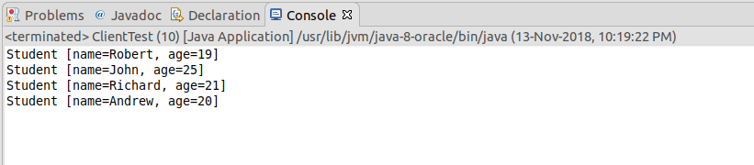

Stream Operation – Intermediate & Terminal:

There are many useful operations that can be performed on a stream.

long count = list.stream().distinct().count();

So, the distinct() represents an intermediate operation which creates a new stream of unique elements of the previous stream. And the count() is a terminal operation, which returns the stream size.

They are divided into multiple intermediate operations(return Stream<T>) and Terminal operations(return a result of definite type). It can also be a chaining operations.

ClientTest.java

package com.java8;

import java.util.ArrayList;
import java.util.List;
import java.util.stream.Stream;

public class ClientTest {

public static void main(String[] args) {

List<String> list = new ArrayList<>();
list.add("Sean");
list.add("Martin");
list.add("Frank");
list.add("Robert");
list.add("Andrew");
list.add("Rich");
list.add("John");

Stream<String> listStream = list.stream(); // it returns a Collection object, so it is an intermediate operations.
Stream<String> distinct = listStream.distinct();
long count = distinct.count();
System.out.println(count);

System.out.println(list.stream().distinct().count()); // This is the chaining operation.

System.out.println(distinct.count());
}

}

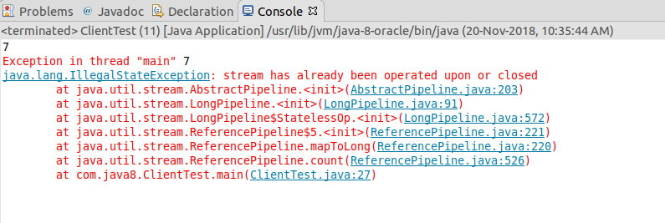

Note : Once the stream is consumed, we can’t reuse it. It will throw error as “Stream has already been operated or closed”.

Iterating Operation:

Stream API helps to substitute for, for-each and while loops. It allows concentrating on operation’s logic, but not on the iteration over the sequence of elements. Example :

for(String string : list)
{
if(string.contains(‘a’))
return true;
}

In Java 8 we can do this in the below way.

boolean isExist = list.stream().anyMatch(element->element.contains(“a”));

package com.java8;

import java.util.ArrayList;
import java.util.List;
import java.util.stream.Stream;

public class ClientTest {

public static void main(String[] args) {

List<String> list = new ArrayList<>();
list.add("Sean");
list.add("Martin");
list.add("Frank");
list.add("Robert");
list.add("Andrew");
list.add("Rich");
list.add("John");

Stream<String> listStream = list.stream(); // it returns a Collection object, so it is an intermediate operations.
Stream<String> distinct = listStream.distinct();
long count = distinct.count();
System.out.println(count);

System.out.println(list.stream().distinct().count()); // This is the chaining operation.

//System.out.println(distinct.count());

System.out.println(list.stream().anyMatch(s->s.contains("A")));
}

}

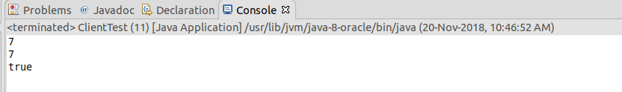

Filtering Operation :

The filter() method allows us to pick stream of elements which satisfy a predicate.

e.g.

Stream<String> stream = list.stream().filter(element -> element.contains(“S”));

This code creates a Stream<String> and filter each element and creates a new String stream if the element contains S.

Matching Operation :

Stream API gives a handy set of instruments to validate elements of a sequence according to some predicate. To do this one of the following method can be used : anyMatch(), allMatch(), noneMatch(). Those are terminal operations.

System.out.println(list.stream().anyMatch(s->s.contains("M")));//true
System.out.println(list.stream().allMatch(s->s.contains("Sean"))); // false
System.out.println(list.stream().noneMatch(s->s.contains("Martin1"))); // true

package com.java8;

import java.util.ArrayList;
import java.util.List;
import java.util.stream.Stream;

public class ClientTest {

public static void main(String[] args) {

List<Student> stuList = new ArrayList<>();
stuList.add(new Student("Andreaw",27));
stuList.add(new Student("Smitha",22));
stuList.add(new Student("Joahn",24));
stuList.add(new Student("Dreaw",29));
stuList.add(new Student("Martin",33));

Stream<Student> stuStream = stuList.stream().filter(e->e.getAge()>25);
stuStream.forEach(System.out::println);

System.out.println("--------------------------------------");

System.out.println(stuList.stream().allMatch(e->e.getName().contains("a")));
System.out.println(stuList.stream().anyMatch(e->e.getAge()>35));
System.out.println(stuList.stream().anyMatch(e->e.getAge()>30));
System.out.println(stuList.stream().noneMatch(e->e.getAge()>55));

}

}

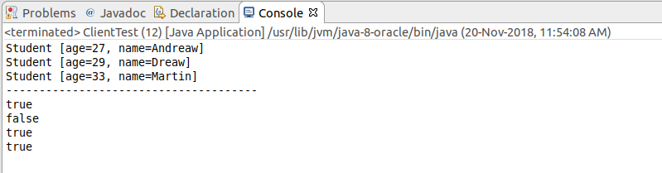

Map and FlatMap:

The usecase is : I have list of string of numbers. Now I have to return a list of Integer of even number.

The map() function is a method in the Stream class which is used to transform one object into other by applying a function. By using the map() function, we can convert a list of String into a List of Integer by applying the Integer.valueOf() method to each String on the input list. The map() function will do the transformation for us. It is also an intermediate Stream operation which means we can call other Stream methods, like a filter, or collect on this to create a chain of transformations.

Filter() - it filters elements based upon a condition you gave it. For example, if your list contains numbers and you only want numbers, then you can use the filter method to only select a number that is fully divisible by two.
The filter method essentially select elements based upon a condition you provide. That's the reason that the filter (Predicate condition) accepts a Predicate object, which provides a function that is applied to a condition. If the condition evaluates true, then the object is selected. Otherwise, it will be ignored. The filter() method is also lazy which means that it will not be evaluated until you call a reduction method, like collect, and it will stop as soon as it reaches the target.

We are almost done. But, so far, we only have the Stream of even integers — not the List of even Integers and that's why we need to use them. Since we need a List, I called collect(Collectors.toList()), which will accumulate all even numbers into a List and return.

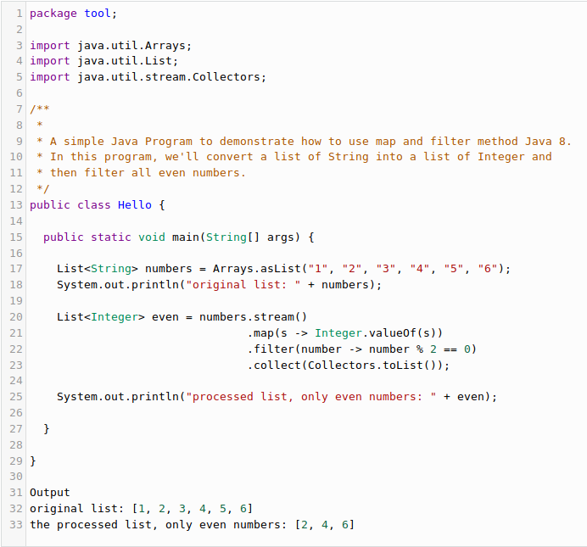

flatMap() is the combination of a map and a flat operation i.e, it first applies map function and than flattens the result.

package com.java8;

import java.util.Arrays;
import java.util.List;
import java.util.stream.Collectors;

public class ClientTest {

public static void main(String[] args) {

List<Integer> PrimeNumbers = Arrays.asList(5, 7, 11,13);
List<Integer> OddNumbers = Arrays.asList(1, 3, 5);
List<Integer> EvenNumbers = Arrays.asList(2, 4, 6, 8);
List<List<Integer>> listOfListofInts = Arrays.asList(PrimeNumbers, OddNumbers, EvenNumbers);
System.out.println("The Structure before flattening is : " +listOfListofInts);
listOfListofInts.stream().forEach(System.out::println);
System.out.println("--------------------------");
listOfListofInts.stream().flatMap(a->a.stream()).forEach(System.out::println);
System.out.println("--------------------------");
List<Integer> listofInts =listOfListofInts.stream().flatMap(a->a.stream()).collect(Collectors.toList());
System.out.println("The Structure After flattening is : " +listofInts);

}

}

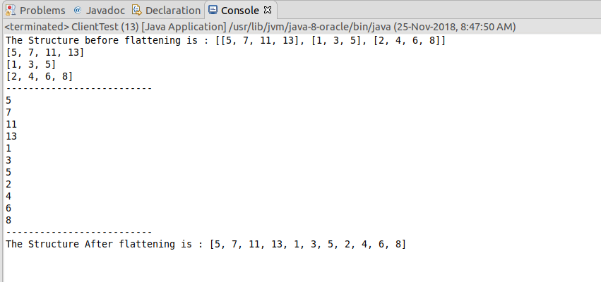

JAVA Stream Infinite Operation :

Each Stream operations are divided into 2 kinds of oerations. Intermediate Operations and Terminal Operations.

Intermediate Operations are not executed until some terminal operations are invoked. They’re composed forming a pipeline of stream execution. Executing an intermediate operation doesn’t actually perform any operation, instead creates a new stream after applying the predicate method and this method will be called when the terminal operation is executed.
Different methods are :
1. filter()
2. map()
3. flatMap()
4. distinct()
5. sorted()
6. peek()
7. limit()
8. skip()

Terminal Operations may traverse the stream to produce the result. After the terminal operation is performed, the stream pipeline is considered consumed and it can no longer be used. In almost all cases, terminal operations are eager, completing their traversal of the data source and processing of the pipeline before returning. Each of the operations will trigger execution of all intermediate operations.

1. forEach()
2. toArray()
3. reduce()
4. collect()
5. min()
6. max()
7. count()
8. anyMatch()
9. allMatch()
10. noneMatch()
11. findFirst()
12. findAny()

Infinite Stream :
Let’s say that we want to create an infinite stream of elements from zero that will be incremented by two. Then we need to limit that sequence before calling the terminal operations. It’s crucial to use a limit() method before executing a collect() method that is a terminal operation, otherwise the program will be executed infinitely.

Stream<Integer> infiniteStream = Stream.iterate(0,i->i+2); // it is a static method
List<Integer> collect = infiniteStream.limit(10).collect(Collectors.toList());

Print first 10 Integers which are even.

import java.util.List;
import java.util.stream.Collectors;
import java.util.stream.Stream;

public class ClientTest {

public static void main(String[] args) {

Stream<Integer> infiniteStream = Stream.iterate(0, i->i+2);
List<Integer> collectList = infiniteStream.limit(10).collect(Collectors.toList());
collectList.stream().forEach(System.out::println);

}

}

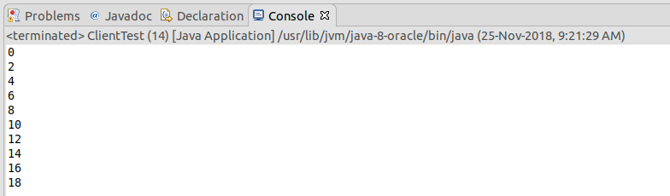

Print the first 10 Integers which are divisible by 5 or 3.

import java.util.List;
import java.util.stream.Collectors;
import java.util.stream.Stream;

public class ClientTest {

public static void main(String[] args) {

Stream<Integer> infiniteStream = Stream.iterate(0, i->i+2);
List<Integer> collectList = infiniteStream.filter(i->i%5==0||i%3==0).limit(10).collect(Collectors.toList());
collectList.stream().forEach(System.out::println);

}

}

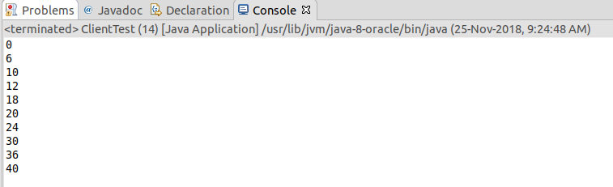

Infinite Stream of Custom Type Elements:

Let’s say that we want to create an infinite stream of random UUIDs. The first step of acheiving this using Stream API is to create a supplier of those random values :
Supplier<UUID> randomUUIDSupplier=UUID::randomUUID;
When we define a supplier we can create an infinite stream by using generate():

Stream<UUID> infiniteStreamOfRandomUUID = Stream.generate(randomUUIDSupplier);

Then we can take a N number of elements from that stream. We need to remember to use a limit() method if we want to complete our program to finish in a finite time.

List<UUID> randomInts = infiniteStreamOfRandomUUID.skip(10).limit(10).collect(Collectors.toList());

import java.util.List;
import java.util.UUID;
import java.util.function.Supplier;
import java.util.stream.Collectors;
import java.util.stream.Stream;

public class InfiniteStreamCustomAPI {

public static void main(String[] args) {

Supplier<UUID> randomUUIDSupplier=UUID::randomUUID;
Stream<UUID> infiniteStreamOfRandomUUID = Stream.generate(randomUUIDSupplier);
List<UUID> randomInts = infiniteStreamOfRandomUUID.skip(10).limit(10).collect(Collectors.toList());
randomInts.forEach(System.out::println);

}

}

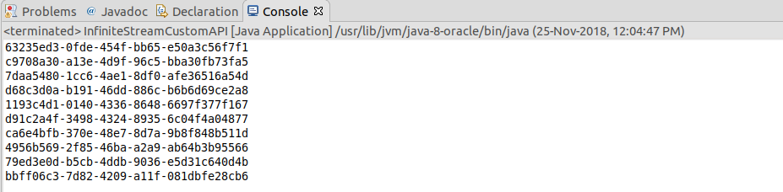

Stream Creation :

There are many ways to create the stream object. Once it is created and consumed we can’t use it further. That’s why multiple stream instances can be created from a single source.

- Empty Stream :
Stream<String> streamEmpty = Stream.empty(); // empty is a static method which is defined in Stream Interface.

- Stream of Collection : Stream can be created from any type of Collection. Collection<String> collection = Arrays.asList(“a”,”b”,”c”);
Stream<String> streamOfCollection = collection.stream();

- Stream of Array : Array can also be the source of Stream.
Stream<String> streamOfArray = Stream.of(“a”,”b”,”c”);
String[] arr= new String[]{“a”,”b”,”c”};
Stream<String> streamOfArrayFull = Arrays.stream(arr);
Stream<String> streamOfArrayPart = Arrays.stream(arr,1,3);
- Stream.builder() : When builder is used the desired type should be additionally specified in the right part of the statement, otherwise the build() method will create an instance of the Stream<Object> : Stream<String> streamBuilder = Stream.<String>builder().add(“a”).add(“b”).add(“c”).build();
- Stream Generate : Generate method accepts a Supplier<T> for element generation. As the resulting stream is infinite, developer should specify the size of the stream otherwise generate() will work until it reaches the memory limit: Stream<String> streamGenerated = Stream.generate(()->”element”).limit(10); ---- this code will generate a sequence of ten strings with the value - “element”.
- Stream.iterate() : Stream<Integer> streamIterate = Stream.iterate(40,i->i+2).limit(10);
The first parameter of iterate method is the first element of the generated Stream.
- Stream of Primitives : Java 8 offers a possibility to create streams out of three primitive types : Int, long and Double. As Stream<T> is a generic interface and there is no way to use primitives as a type parameter with generics, three new Special Interfaces were created : IntStream, LongStream, DoubleStream.

Using the new interfaces alleviates unnecessary auto-boxing allows increased producitivity :

IntStream intStream = IntStream.range(1,3); --- range(int startInclusive, int endExclusive) method creates an ordered stream from the first parameter to the second parameter. It increments the value of subsequent elements with the step equal to 1. The result doesn’t include the last parameter, it is just an upper bound of the sequence.
LongStream longStream = LongStream.rangeClosed(1,3); --- rangeClosed(int startInclusive, int endInclusive) method does the same with only one difference – the second element is included. These 2 methods can be used to generate any of the two types(int and long) of streams of primitive.

Random random = new Random();
DoubleStream doubleStream = random.doubles(3);

- Stream of String : String can also be used as a Source for creating a stream. With the help of cahrs() method of the string class, Since there is no interface CharStream in JDK, then IntStream is used to represent a stream of chars instead. IntStream streamOfChard = “abc”.chars(); The following example breaks a string into sub-string according to speciified Regex : Stream<String> streamOfString = Pattern.compile(“,”).splitAsStream(“a”,”b”,”c”);
- Stream of File : Java NIO class allows to generate a Stream<String> of a text file through the lines() method. Every line of the text becomes an element of the stream :
Path path = Paths.get(“C:\\file.txt”);
Stream<String> streamOfStrings = Files.lines(path);
Stream<String> streamWithCharset = Files.lines(path,Charset.forName(“UTF-8”));
The charset can be specified as the argument of the lines() method.

package com.java8;

import java.io.IOException;
import java.nio.charset.Charset;
import java.nio.file.Files;
import java.nio.file.Path;
import java.nio.file.Paths;
import java.util.stream.Stream;

public class StreamWithFile {

public static void main(String[] args) {

Path path = Paths.get("test.txt");
try (Stream<String> lines =Files.lines(path)){
lines.forEach(System.out::println);
} catch (IOException e) {
e.printStackTrace();
}

System.out.println("--------------------------------------");
try(Stream<String> lines =Files.lines(path,Charset.forName("UTF-8")))
{
lines.forEach(System.out::println);
}
catch(IOException e)
{
e.printStackTrace();
}
}
}

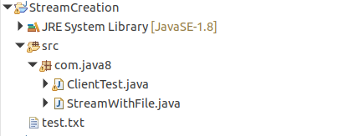

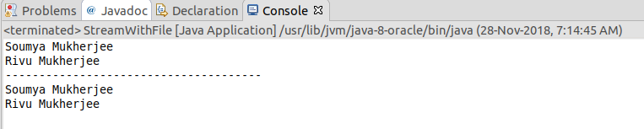

Referencing Stream:

package com.java8;

import java.util.Optional;
import java.util.stream.Stream;

public class ClientTest {

public static void main(String[] args) {

Stream<String> stream = Stream.of("a","b","c","ab","cd","bd").filter(e->e.contains("b"));
Optional<String> optional = stream.findAny(); // stream is consumed here and it is a terminal operation
System.out.println(optional.get());

// if we want to reuse the same stream API it will throw runtime exception java.lang.IllegalException.
Optional<String> findFirst = stream.findFirst();
}
}

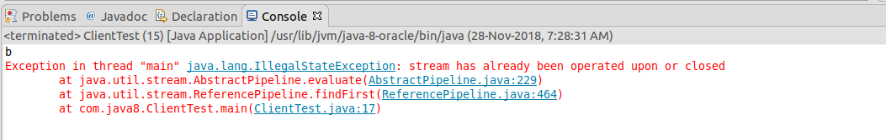

Now if we want to reuse the same stream API reference then follow the below approach :

package com.java8;

import java.util.List;
import java.util.Optional;
import java.util.stream.Collectors;
import java.util.stream.Stream;

public class ClientTest {

public static void main(String[] args) {

List<String> streamCollection = Stream.of("a","abc","c","ab","cd","bd").filter(e->e.contains("b")).collect(Collectors.toList());
Optional<String> optional = streamCollection.stream().findAny(); // stream is consumed here and it is a terminal operation
System.out.println(optional.get());

// if we want to reuse the same stream API it will throw runtime exception java.lang.IllegalException.
Optional<String> findFirst = streamCollection.stream().findFirst();
System.out.println(findFirst.get());
}
}

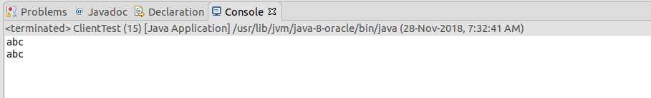

Stream Pipeline :

To perform a sequence of operations over the elements of the data source and aggregate their results, three parts are needed – the source, intermediate operations(s) and a terminal operation.

Intermediate Operation(s) return a new modified stream.
e.g. to create a new stream of the existing one without few elements the skip() method should be used :

Stream<String> onceModifiedStream = Stream.of(“abcd”,”bbcd”,”cbcd”).skip(1);

If more than one modification is needed, intermediate operations can be chained. Assume that we also need to substitute every element of current Stream<String> with a sub-string of few characters. This will be done by applying skip() and map().

Stream<String> twiceModifiedStream = Stream.of(“abcd”,”bbcd”,”cbcd”).skip(1).map(e->e.substring(0,3));

Intermediate Operations will not be invoked until there is a terminal operation. One terminal operation can be applied for a stream.

List<String> list = Arrays.asList(“abcd”,”bbcd”,”cbcd”);
long size = list.stream().skip(1).map(e->e.substring(0,3)).sorted().count();

Stream Reduction :

The API has many terminal operations which aggreagtes a stream to a type or to a primitive, for example, count(), min(), max(), sum(). But these operations work according to the predefined implementation. And what if a developer needs to customize a stream’s reduction mechanism? There are two methods which allow to do this – the reduce() and the collect() methods.

The reduce() method :
There are 3 variations of this method, which differ by their signatures and return types. They can have the following parameters :
identity : the initial value for an accumulator or a default value if a stream is empty and there is nothing to accumulate.
Accumulator : a function which specifies a logic of aggreagtion of elements. As accumulator creates a new value for every step of reducing, the quantity of new values equals to the stream’s size and only the last value is useful.

Combiner : a function which aggreagtes results of the accumulator. Combiner is called only in a parallel mode to reduce results of accumulators from different threads.

package com.java8;

import java.util.Arrays;
import java.util.OptionalInt;
import java.util.stream.IntStream;

public class ClientTest {

public static void main(String[] args) {

// 1+2+3
OptionalInt reduced = IntStream.range(1,4).reduce((a,b)->(a+b));
System.out.println(reduced.getAsInt());

System.out.println("---------------------------------");

// 10+1+2+3
int reducedTwoParams = IntStream.range(1,4).reduce(10, (a,b)->(a+b));
System.out.println(reducedTwoParams);

System.out.println("---------------------------------");

Integer reducedwithThreeParam = Arrays.asList(1,2,3).parallelStream().reduce(10, (a,b)->(a+b), (a,b)->{
System.out.println("Combiner was called "+a+"\t"+b);
return a+b;
});
System.out.println(reducedwithThreeParam);

/*First, each value will be added with the initial values : 11, 12, 13 as the summation logic is mentioned in accumulator.
* Now these values will be passed to combiner : 11, 12, 13
* Now these three values will be passed to combiner, and it will accumulate again : 13+12 = 25; 25+11 = 36; Hence combiner is called twice. */

}

}

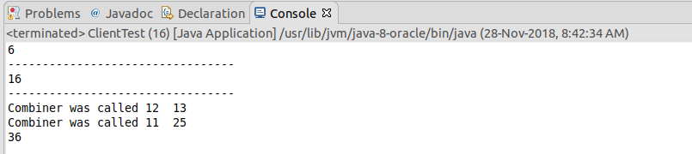

Collect API with reduce():

package com.java8;

import java.util.Arrays;
import java.util.Collections;
import java.util.IntSummaryStatistics;
import java.util.List;
import java.util.Map;
import java.util.Set;
import java.util.stream.Collectors;

public class StreamReductionCollectionTest {

public static void main(String[] args) {

// Converting stream to collection
List<Product> productList = Arrays.asList(new Product(23,"Potatos"), new Product(25,"Onion"),new Product(30,"Tomato"), new Product(30,"Vendi"), new Product(25,"Mirchi"));
List<String> nameList = productList.stream().map(Product::getName).collect(Collectors.toList());
nameList.forEach(System.out::println);

System.out.println("------------------------------");
// Reduce to String

String nameString = productList.stream().map(Product::getName).collect(Collectors.joining(",", "[", "]"));
System.out.println(nameString);

String nameString2 = productList.stream().map(Product::getName).collect(Collectors.joining());
System.out.println(nameString2);

String nameString3 = productList.stream().map(Product::getName).collect(Collectors.joining(","));
System.out.println(nameString3);

// Average Price

double averagePrice = productList.stream().collect(Collectors.averagingInt(Product::getPrice));
System.out.println(averagePrice);

System.out.println("------------------------------");
// use of SummarizingInt method
IntSummaryStatistics collect = productList.stream().collect(Collectors.summarizingInt(Product::getPrice));
System.out.println(collect);

IntSummaryStatistics collect2 = productList.stream().collect(Collectors.summarizingInt(Product::getPrice));
System.out.println(collect2.getSum()); // getAverage/ getCount/ getMax/ getMin --- these methods are also available.

System.out.println("------------------------------");

Map<Integer, List<Product>> collect3 = productList.stream().collect(Collectors.groupingBy(Product::getPrice));
collect3.forEach((k,v)->{System.out.println(k+"\t"+v);});

System.out.println("------------------------------");
System.out.println("------------------------------");

// Dividing the stream's elements into groups according to some predicate

Map<Boolean, List<Product>> collect4 = productList.stream().collect(Collectors.partitioningBy(p->p.getPrice()>25));
collect4.forEach((k,v)->System.out.println(k+"\t"+v));

// Pushing the collectors to perform some additional transformation
System.out.println("------------------------------");
Set<Product> collect5 = productList.stream().collect(Collectors.collectingAndThen(Collectors.toSet(), Collections::unmodifiableSet));
collect5.forEach(System.out::println);

}

}

